From: https://www.zerohedge.com/geopolitical/luongo-opening-salvos-thrown-what-are-putins-next-steps-ukraine
BY TYLER DURDEN
THURSDAY, MAR 03, 2022 - 11:30 AM

Authored by: Tom Luongo, 35 comments

Opening Salvos Thrown – What Are Putin’s Next Steps in Ukraine?
Last week I wrote that Russian President Vladimir Putin rewrote the rules for the geopolitical game board. A week into his campaign to officially “demilitarize and de-Nazify Ukraine” it’s clear to me that Putin’s ambitions lie far beyond this stated goal.
He will, however, stick to that script until that part of the campaign is complete.
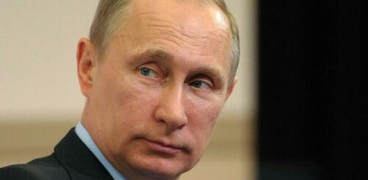
Today I want to start outlining where we go next and to do that we have to describe where we are.
Looking around the reports that are the most credible (and properly bracketing for any partisanship) we are staring at a complete, effective neutralization of the Ukrainian Armed Forces (UAF) to hold any of the ethnically-dominant areas of Ukraine.
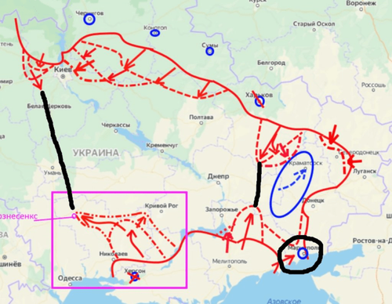
In a post for my patrons on February 25th, responding to an excellent article by Alistair MacLeod I wrote the following:
MacLeod: Both sides probably do not know how fragile the Eurozone banking system is, with both the ECB and its national central bank shareholders already having liabilities greater than their assets. In other words, rising interest rates have broken the euro system and an economic and financial catastrophe on its eastern flank will probably trigger its collapse.
I’ve been banging my shoe on this table for 3 years now. If the US/NATO respond with some kind of guerilla war here to hang Ukraine like an albatross around Putin’s neck, as we should expect, then Europe is in big trouble financially.
Because the financial war will keep escalating as Putin responds militarily. Remember, he’s openly threatened the ‘decision makers’ here. And no amount of mealy-mouthed CIA/MI6 disinformation will deter him from action anymore.
This is always what I meant by “spooks start civil wars, militaries end them.” There is no more War for Ukraine.
I still believe that. This isn’t a war for Ukraine, it’s a war for the future of the entire world. Ukraine represents the hill both Davos and Russia have chosen to live or die on.

The Afghanistan Gambit
Davos has refused to let President Zelensky surrender because if he does then legally there is no more war to sanction Russia with. It’s not Putin’s War at that point, it is a settled conflict and terms negotiated.
At that point what’s left of Ukraine can be carved up into pieces. It’s way too early for that to occur, so you’ll see constant threats of peace talks, but that’s only to assuage the fears of the capital markets, which is where Davos has the most control over the situation.
The primary goal of the information war from the West is to push capital markets as far in its favor as possible, keeping things within the bounds of the ‘acceptable’ to avoid any short-term pain. Gold is still under it’s all-time high, which is just hilarious.
That said, in that same post I put up this map of a future Ukraine which I felt, conservatively, would be in effect by the end of this year. Events are moving far faster than that, however.
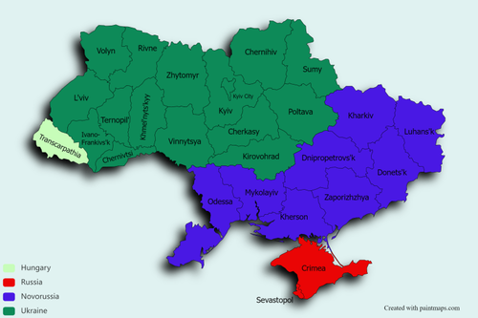
Chernihiv and Sumy are also in play, as is Lviv as a bargaining chip to Poland. As Fmr. Col. Douglas Macgregor pointed out on Fox News recently, everything east of the Dnieper River will become part of a new Novorussia, if not part of the Russian Federation.
Clearly this is Putin’s initial goal, the partitioning of Ukraine. He’s moved militarily, the EU and the rest of the West have responded financially. Their hope is to turn Ukraine into a quagmire, a la Afghanistan (per Hillary Clinton’s recent remarks), which they hope Russia will not be able to sustain after being choked off from the global economy.
The financial sanctions regime put in place so far are brutal but also full of holes wide enough for Putin to maneuver within and around because of the well understood facts of Russia’s dominance as a global supplier of life-sustaining commodities for the entire world.
This is an asymmetric war.
There isn’t much farther the West can go financially. They’ve seized Bank of Russia foreign assets, for pity’s sake. What other weapons do they really have in their arsenal which can threaten Russia with?
They have, in effect, executed their ["] nuclear ["] first strike against Russia. Once you’ve gone nuclear, where do you go next? Real nukes? Yes, that’s a possibility, sadly, given the people we’re talking about.
On the other hand, Russia has so far only committed the necessary troops to neutralize Ukraine. So, in this respect, big advantage Russia.
Facts on the ground are facts. Russia has taken territory it can maintain. By not targeting civilians or civilian infrastructure, Russia has put itself in a very good position to not face an insane insurgency which the West can finance in the way that it has in past conflicts.
Much of NATO’s in-country assets have been neutralized. And you know this because the propaganda and rhetoric have been so thoroughly crude, cartoonish and strident. Again, ask why the financial and informational war has been so intense?
Is it because the West thinks it’s winning or because it’s trying desperately to pivot domestic populations to solidarity after losing massive credibility during the last year with COVID-19 related lockdowns, vax passes, and the unpersoning of whole swaths of Western society?

The Real Russian Cauldron
Now let’s ask the next question that keeps coming up.
Why has Putin not shut off the gas to a Europe that is rapidly running out of it?
Because to do so would target civilian populations. If he’s not targeting civilians in Ukraine to minimize their anger at being invaded, then why would he use that weapon now against civilians in Germany who hold the key to getting overthrowing the insane politicians and oligarchs who provoked this war in the first place?
It doesn’t make any strategic sense. It also speaks to a kind of confidence in Russia’s military position in Ukraine, thereby lending credence to the reports that Russia is achieving her strategic goals on the ground in Ukraine.
Okay, that’s the lay of the land.
So, what are Putin’s real goals? Like I said at the outset, nothing less than breaking the back of Davos and their agents in the US/UK who have tormented Russia for more than a century.
How does he achieve that goal?
Putin is creating incontrovertible facts which his opponents must respond to. Again, he’s setting the operational tempo, like I said last week.
Their counter-moves are insipid and predictable. Ukraine has asked for admission into the EU. The EU is open to this. Georgia is now doing the same thing. Turkey is livid. Hungary is not getting involved.
No one is willing to actually send arms to Ukraine.
What does the EU achieve by adding Ukraine? Do they think because they signed a piece of paper with a person who is de facto not in charge of his country going to change the facts on the ground there?
Do they still think “stroke of the pen, law of the land, kinda cool” [Oct 6, 2012] matters at this point?
Because if the EU accepts Ukraine into its ranks, then it will be responsible for the next stage of escalation, not Putin. It will then have to figure out how to oust the Russians from their territory.
Last night President Sundowner made the entire US State of the Union about Ukraine. Do they really think a president with an approval rating that is, at best 37%, capable of marshalling the US into fighting a war for Europe against Russia after bankrupting us with NATO for three generations?
If they are, they are more delusional than even I’ve contemplated at this point.
Is NATO prepared to expand now into Ukraine under the umbrella of EU membership?
What’s obvious to me is the neocons and neoliberals controlling the West think they can turn Ukraine into a quagmire for Putin, but what if Putin thinks he can turn Ukraine into a quagmire for them?
Russia is not capable of conquering Europe. But he doesn’t need to defeat them. He just needs to create a version of the map I posted above.

The Limits of Money Wars
If Putin and Russia have achieved, or are about to achieve, all of their military goals in Ukraine, what do they do to secure those gains?
They have to neutralize the financial war waged against them and create an environment where Europe spends money it doesn’t have, with failing political capital domestically, and bankrupts them completely.
And the first move along those lines was just announced by the Russian Finance Ministry today (VPN and Deepl translator needed).
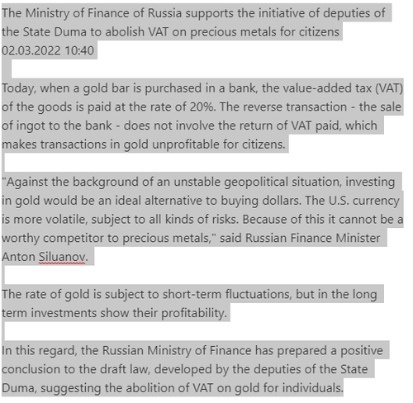
What does this mean? It means simply that Russia has now, in effect, begun the remonetization of gold for domestic purposes. By removing the VAT on gold purchases Russian citizens can now offset their currency risk with gold and stabilize the domestic monetary situation.
The first step in offsetting financial warfare from the West is allowing the domestic population to be immune to collapses in their currency from foreign actors pulling capital out of the country. Companies doing international business now have an alternative to hold time deposits which are far less volatile than the ruble without penalty. Gold becomes the coin of Russia’s international business.
It’s the beginning of the process of draining physical gold from the global market and control over its price by the ponzi schemes that are the COMEX and the LBMA.
This is a first step in rebuilding confidence in the Russian banking system rather than what we’re seeing in the West which is the ritualistic assault on privacy, wealth generation and the value of our labor, which is degrading rapidly thanks to inflation, which will rage from here as all energy and commodity markets are scared to death of Davos’ financial war on Russia.
As Luke Gromen pointed out on Twitter this is the big signal that the petrodollar system is headed for the ashbin of history.
With the global oil market in a complete state of shock as no one wants to run afoul of US and/or EU sanctions on Russian energy, the price of oil here potentially goes parabolic. At that point reality hits the money masters squarely in the face.
Those that brave the waters will get their oil at a steep discount, those that don’t will pay through the nose, further accelerating the decline of those economies as inflation spirals out of control and the people put the blame, not on Putin, but on the people in charge.
Moreover, Russia has kept the gas flows going to ensure that money keeps flowing into the country to finance further expansion of its gold reserves.
The current shock will abate. Russia is not Iran. It can insure its own tanker fleet. It can deliver the oil. If Iran could survive what Trump did to them, Russia can thrive under this new regime, changing the entire flow of capital around the world.
Now, I want to turn your attention to the other news of which further corroborates that Davos and Europe are trapped. FOMC Chair Jerome Powell testified today telling the world that the Fed will still hike 25 basis points in March. Bullard came out and said the Fed has to withdraw accommodation to maintain its credibility.
Further Powell blamed both the Fed and Congress for inflation. It’s a result of too much spending.
Powell even floated the idea that the world can have more than one reserve currency (!!). Meanwhile Biden is talking about bringing back Build Back Better and sending us down the road to financial ruin.
The fight between Davos and the Fed, which I identified last summer is real, folks. That leaves a belligerent yet impotent Europe caught between the Scylla of a Fed drying up the global supply of dollars and the Carbides of a Russian military capable of withstanding anything Europe throws at them if the US doesn’t get involved, i.e. this doesn’t go nuclear.
NATO isn’t getting involved in Ukraine even if Ukraine becomes an EU member. They can have the landlocked rump of what’s left over. If Putin is smart, which he is, he will offer the Poles Lviv and Hungary Transcarpathia. The EU gets the dregs.
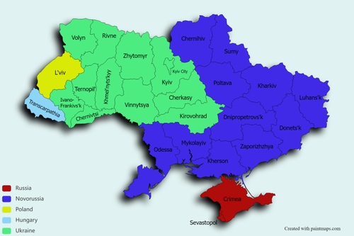
It’s clear from the wailing and gnashing of the Neocon/Neolibs that they want Putin Milosevic’d for daring to put them in this position. They still dream of overthrowing him. It’s also clear that there are a lot of people who are not down with the willful destruction of the current global economy within the upper reaches of US policy makers and European corporate boards.
This is the real fight for the future and if Davos thinks extreme demand destruction will be tolerated for any length of time over a regional conflict like Ukraine because it’s their ox being gored, then this war, while still raging is, in effect, already over.
* * *
Join My Patreon if you like seeing two moves ahead
BTC: 3GSkAe8PhENyMWQb7orjtnJK9VX8mMf7Zf
BCH: qq9pvwq26d8fjfk0f6k5mmnn09vzkmeh3sffxd6ryt
DCR: DsV2x4kJ4gWCPSpHmS4czbLz2fJNqms78oE
LTC: MWWdCHbMmn1yuyMSZX55ENJnQo8DXCFg5k
DASH: XjWQKXJuxYzaNV6WMC4zhuQ43uBw8mN4Va
WAVES: 3PF58yzAghxPJad5rM44ZpH5fUZJug4kBSa
ETH: 0x1dd2e6cddb02e3839700b33e9dd45859344c9edc
DGB: SXygreEdaAWESbgW6mG15dgfH6qVUE5FSE
Viewers:136,594 Comments:662

